Kickstart My Chart final Report

01/19/2019

Lead Analyst: LaShanti D. Jones

# Overview

Over two billion dollars have been raised using the massively successful crowdfunding service, Kickstarter, but not every project has found success. Of the over 300,000 projects launched on Kickstarter, only a third have made it through the funding process with a positive outcome.

Since getting funded on Kickstarter requires meeting or exceeding the project's initial goal, many organizations spend months looking through past projects in an attempt to discover some trick to finding success. For this week's homework, you will organize and analyze a database of four thousand past projects in order to uncover any hidden trends.

## What are three conclusions we can make about Kickstarter campaigns given the provided data?

1. Theater campaigns are the most popular campaigns based on the given data set.

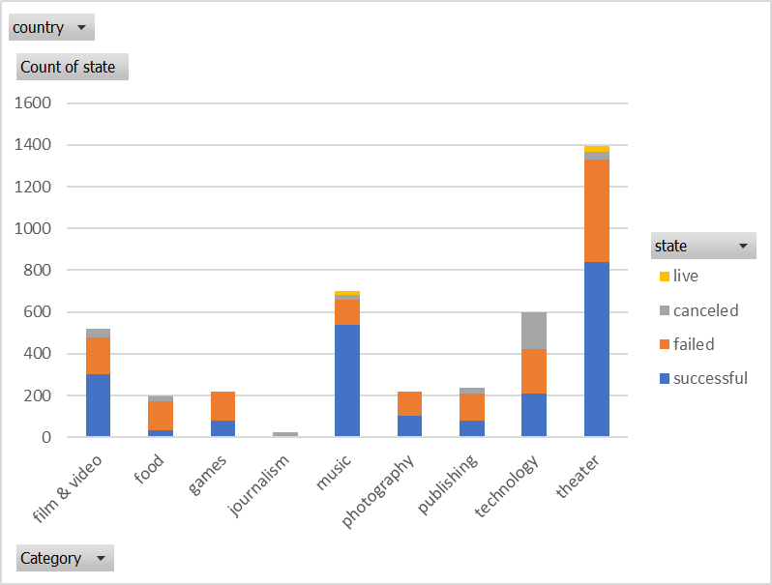

1. Theater campaigns also produce the most failed & successful results in comparison to the other campaign categories based on the given dataset.

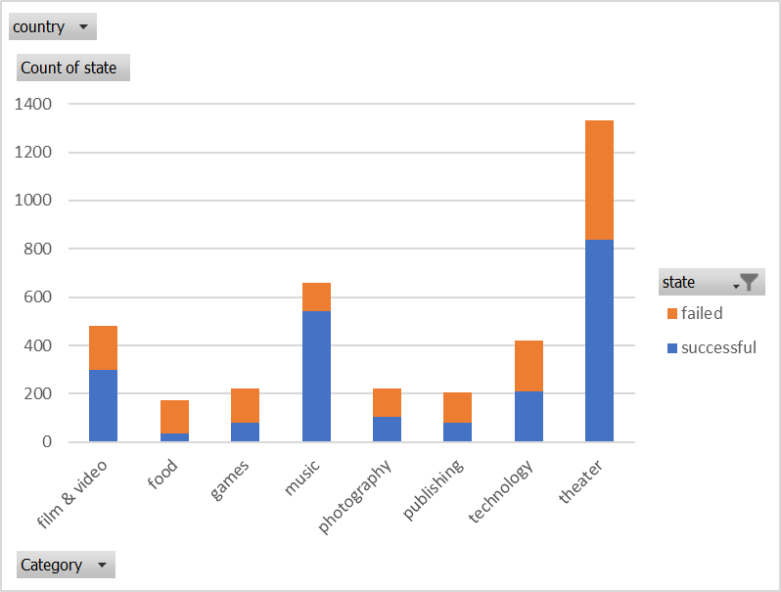

1. Plays are the most successful subcategory based on the given data set.

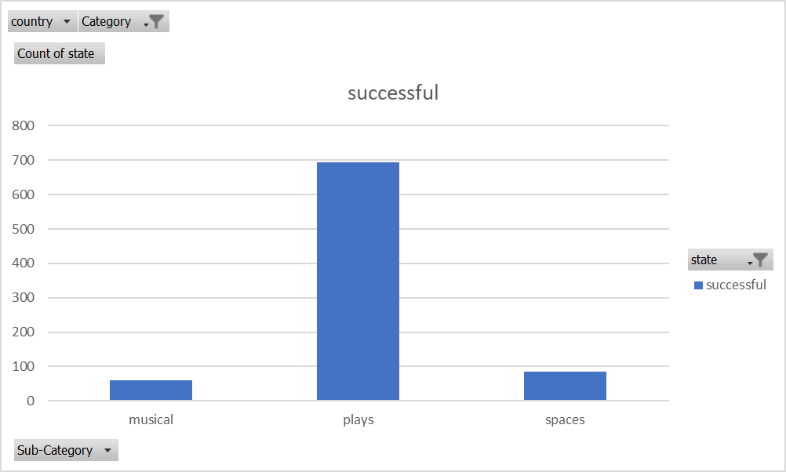

## What are some of the limitations of this dataset?

The data set could expand upon factors such as marketing techniques for each campaign. For example: word of mouth vs. Instagram or any of the other social media platforms.

The data set could expand on first time campaign creator’s vs creators who have launched multiple campaigns.

## What are some other possible tables/graphs that we could create?

1. The average days between the campaign date created and date ended for failed campaigns vs. successful campaigns.
2. The average of successful campaigns that go Live
3. The average pledged based on goal for all cancelled campaigns.
4. The average word count in the blurb for successful campaigns.